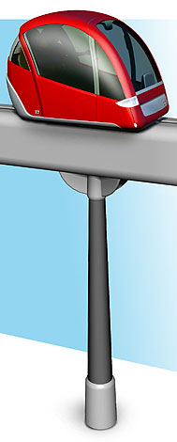
Personal Rapid Transit for Microsoft and Bellevue
By Jerry Schneider and Steve Raney
For Cascadia Center's Feb. 24, 2005 Breaking Gridlock with Technology Conference

This introductory paper will:
- Describe PRT technology
- Explain an associated out-of-the-box paradigm
- Describe how PRT fits within a larger "comprehensive door-to-door mobility" service
- Describe PRT applications for Microsoft campus and downtown Bellevue.
- Comment on the status of PRT technology development
- Explain the main implementation challenges
- Comment on PRT's visual impact

PRT TECHNOLOGY

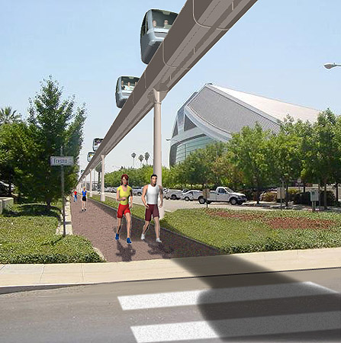
PRT is an elevated monorail system with many three-person, driverless, electric vehicles. It is ideally suited for short "feeder/distributor", shuttle, and "circulation" operations at train stations, airports, office parks, and shopping centers. PRT provides non-stop, no-wait, 30 mph service.

Vehicles travel above ground on 16' elevated "guideway." Stations are located near building entrances. Many stations are situated along the route to minimize walking once the trip ends. Vehicles travel non-stop to their destination along the main guideway at 30 mph, speeding at twice the average speed of autos on congested streets below. Stations are NOT located on the main guideway; instead, stations are located on separate station guideway that branches from the main guideway. Thus, stations are described as "off-line," meaning "not on the main line."

PRT combines concepts from monorail (Disneyland), automated people movers (SeaTac Airport), roller coasters, and automated highway systems (California Governor Schwarzenegger's GM OnStar van drives itself in the science fiction movie The Sixth Day).

Passengers travel alone or with people of their choosing. Vehicle weight minimization greatly reduces the size of the elevated guideway and supporting columns, dramatically reducing construction cost and right of way acquisition. Vehicles flow along the guideway almost like data packets on the Internet, anticipating demand so that wait time is eliminated. In addition to improving commute alternatives, the PRT system eliminates mid-day stranding caused by traditional carpooling/transit, by providing efficient transit to adjoining shops and restaurants.

PRT system capacity is roughly 4,000 person trips per hour per PRT "loop." Systems may have many loops, providing more capacity.

OUT-OF-THE BOX PARADIGM

Recent national studies by the Texas Transportation Institute and the Brookings Institution conclude that there is no 'silver bullet' to reduce traffic congestion. A more accurate conclusion is that our current national tool kit for reducing traffic congestion is ineffective, thus new tools should be developed. Cascadia's "Breaking Gridlock with Technology" Conference understands this need for new, out-of-the-box tools.

Electric trolleys first became operational in 1888, and provided much faster service than the horse carts that they replaced. Cities granted franchise agreements to real-estate speculators who built and operated trolley systems as a means to build new homes. Within a few years, trolleys were the dominant mode of transit. This real-estate driven franchising model is also quite promising for PRT. Franchisees take on the investment risk instead of taxpayers. The current public policy context often focuses only on transportation benefits, but transit works better economically when also used as a means to a real-estate ends. By reducing traffic congestion, PRT enables new real-estate development within suburban areas where traffic congestion currently limits or prohibits growth (such as in Eastern King County).

With the current set of transit tools, transit agencies are often forced into capital-intensive investments using 100-year-old technology, frequently with capital costs in the billions, and with no hope of ever covering annual operating costs. One of the major drawbacks of older transit technology is that riders only come from within a small 20-acre / 500-person area surrounding transit stations. PRT offers a better solution than expensive transit line extension investments. By serving as a feeder to existing transit stations, PRT can bring 20,000 people within a short PRT ride of those transit stations. Thus, PRT can profitably create huge increases in conventional transit ridership. The current insufficient transit toolkit forces an emphasis on adding new subsidized transit, rather than on improving the operating economics of existing transit investments.

COMPREHENSIVE MOBILITY

The transportation political system is broken into many separate and competing agencies (nowhere worse than in Seattle where two huge new systems are locked in an open battle to the death). Within this policy context it is difficult to provide a seamless, customer-centered, multimodal transportation system. But this is what is really needed to get travelers to and from destinations. U.C. Researcher Susan Shaheen defines "comprehensive new mobility" as "pairing clusters of smart technologies with existing transportation options to create a coordinated, intermodal transportation system that could substitute for the traditional auto."

A study of a 20,000-person Palo Alto office park explored the impact of a hypothetical PRT feeder system coupled with comprehensive new mobility. This hypothetical service significantly increased the attractiveness of commuter rail, carpool, vanpool, bicycle, and bus commutes. This new service increased transit market share from 0% to 19.75%, increased carpooling from 9.6% to 32.1%, and shrank solo driving share from 89% down to 45.6%.

Suburban commute alternatives are diagramed below. The PRT Shuttle solves the "last mile" problem, efficiently connecting different commute alternatives to workplaces. A stylized version of a PRT shuttle system is shown below as an oval with many stations blanketing the job center with efficient feeder/distributor service:
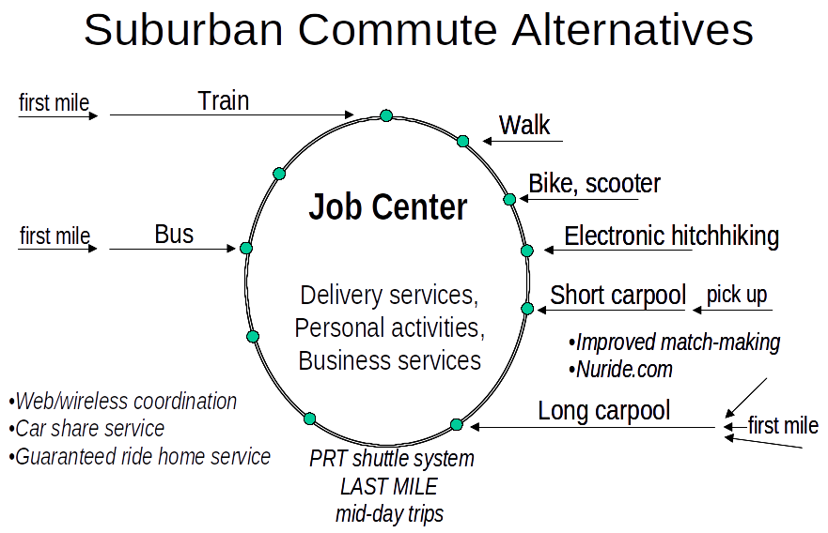
Comprehensive new mobility improves door to door suburban commutes

Of particular note, driving alone requires very little conscious thought. People drive alone following their route out of habit, focusing very little of their mental capacity on the driving. To compete with driving alone, commute alternatives must become simpler.

Train and bus commuters face the "first mile" problem as well: how to get to the train station or bus stop in their home city. If we provide a solution for the last mile (and mid-day stranding) that often provides sufficient motivation for commuters to solve the first mile problem.

Without PRT, carpoolers typically worked in the same building, meaning that finding a carpool partner who lived nearby was a significant challenge. By providing efficient distribution, PRT breaks this restriction. Carpoolers travel to the edge of the employment center, park at the most convenient employer lot, and then ride PRT to reach their workplaces. With 20,000 workers serving as potential carpool matches, the spatial matchmaking probability improves dramatically.

By rapidly connecting within an entire major employment center, PRT provides sufficient scale for centralized commute services such as “guaranteed ride home”, car sharing, and car rental.

PRT APPLICATINS: DOWNTOWN BELLEVUE

The downtown Bellevue PRT system design below was created by UW students in one of Jerry Schneider's classes. There are nine miles of one-way guideway, 24 PRT stations, and roughly six high-capacity loops. Yellow diamonds depict station locations.

Old-fashioned rail technology follows a linear path. In contrast, PRT enables more complex transit network topologies, such as the one below.

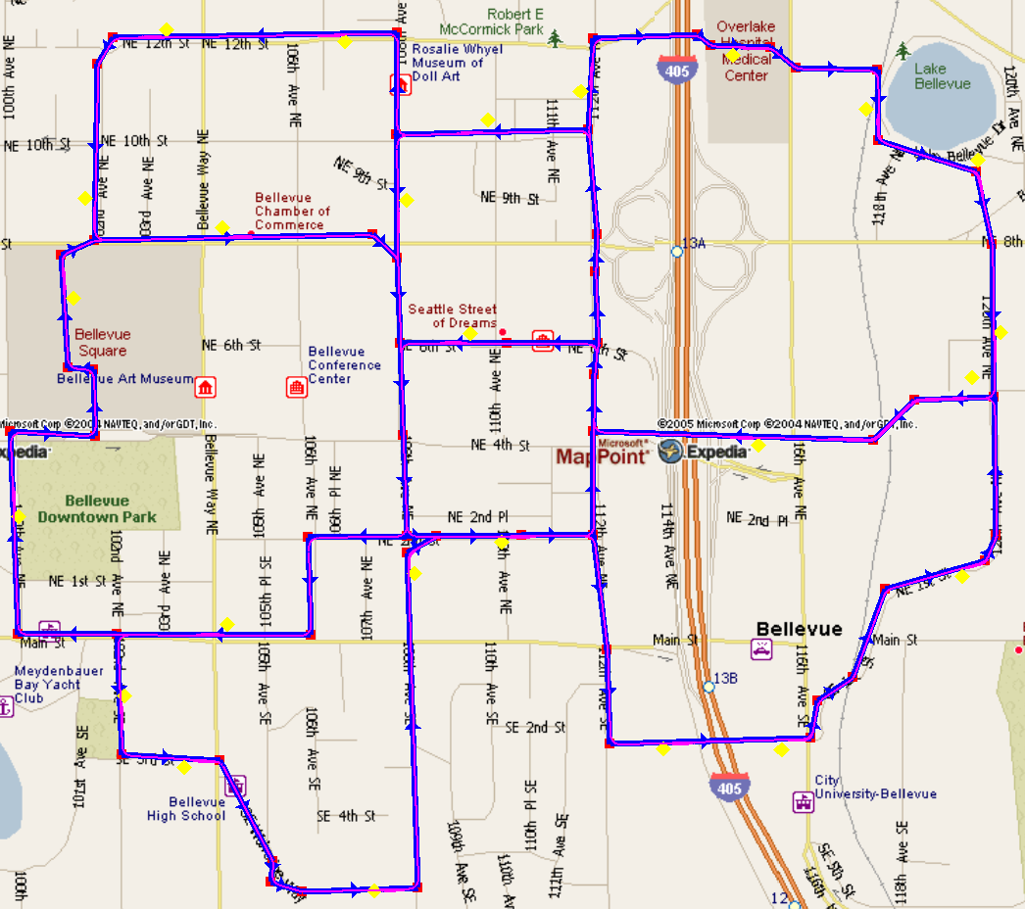

PRT APPLICATIONS: MICROSOFT CAMPUS

Microsoft's three Redmond campuses (Main, West, and RedWest) hold more than 30,000 employees and contractors. Microsoft recently purchased new parcels, and has plans to add another 10,000 to 20,000 employees and 8,500 parking spaces. The local street grid is already overburdened, as the success of Microsoft was not contemplated when the streets were first designed. Some intersections serve more than 30,000 car trips per day.

Microsoft currently has one of the nation's most impressive shuttle bus systems, with 43 buses serving 5,500 campus trips per day, often bring employees to and from remote meetings. While the bus system is state-of-the-art, employees find door-to-door trip times comparable to walking. In contrast, PRT provides local service that is faster than a car, especially when time spent searching for parking spaces (Microsoft is infamous for scarce parking) and time spent walking from distant parking lots is factored in.

A preliminary Microsoft Campus PRT system below shows 29 stations (including one at Pro Sports Club), 9.5 miles of one-way guideway, and five high-capacity loops. Yellow diamonds depict station locations:

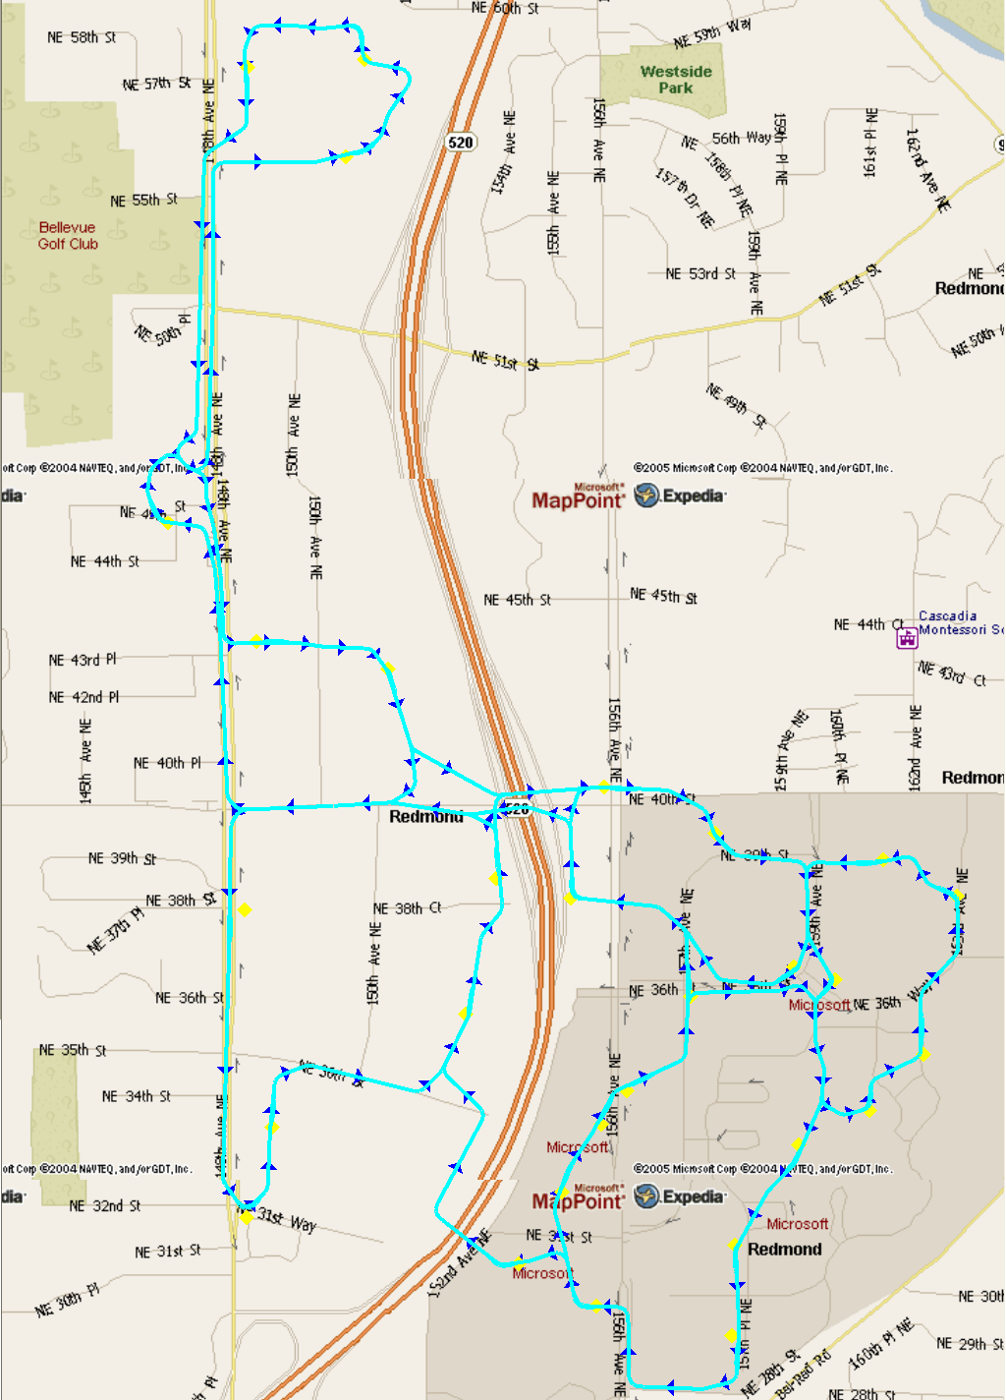

A Microsoft Campus PRT system could be easily extended to connect to Crossroads Shopping Center, other office buildings, and nearby apartments / townhouses.

A simple, rough business case for profitable PRT transit can be easily made. PRT will provide one-time savings of $195M and annual cost savings of $27.3M. The numbers:
- Microsoft's traffic mitigation fee is $4K per each net new employee, but Redmond is willing to count MS's transportation investments against this fee. Thus, 20,000 new employees at $4K per employee = $80M that can be used for the PRT system, rather than paid out as traffic mitigation.
- Microsoft builds multi-story parking garages. Each parking space costs Microsoft $25K. Assume that PRT can save Microsoft the construction of 4K parking spaces, that's $25K * 4K = $100M savings.
- PRT will eliminate the need for the $22M NE 36th Street / 520 overpass. The savings to Microsoft is $15M, the savings to Redmond is $7M.
- Shuttle buses cost roughly $100K per year to operate, including driver salaries, maintenance, and bus lease costs. A PRT system would eliminate the need for Microsoft to fund bus shuttles, saving 43 buses * $100K per bus = $4.3M annual cost savings.
- Conservatively assume that PRT doubles ridership beyond the current 5,500 shuttle bus trips per day. Assume the "burdened" value of time for Microsoft employees is $50 per hour and a PRT system saves 10 minutes for each of 11,000 daily shuttle trips. That's $50/hr * 10/60 hours * 11,000 trips/day * 250 operating days = $23M annual costs savings.

These economics are on the same scale with those found in the Palo Alto office park study, which found combined annual revenue and cost savings of $16.9M, with $326M one-time profit from real-estate redevelopment of 50 acres of reclaimed parking spaces.

An interactive 3D Microsoft campus virtual world is being developed to convey PRT to senior Microsoft executives.

OTHER PRT APPLICATIONS

Should Microsoft campus and downtown Bellevue PRT systems come about, it is probable that PRT would be extended to connect both systems, and be further extended to downtown Redmond. Additional promising PRT application areas include: a) Seattle's South Lake Union area, b) SeaTac and Tukwila, c) downtown Olympia, d) downtown Tacoma, and e) monorail and LRT station feeders to increase ridership. Once PRT is proven, a desire may arise to have "faster than 30 mph PRT" cross Lake Washington.

PRT DEVELOPMENT STATUS

PRT is an emerging technology under development in Minnesota (SkyWeb Express), Texas (Microrail), the United Kingdom (ULTRA), and Korea. The original PRT concept was invented in the U.S. 40 years ago, and has been independently derived on numerous occasions since. SkyWeb has one vehicle and a 60' test track segment. Former Microsoft employees have provided the majority of their funding. A $4M SkyWeb earmark stalled in the Minnesota state 2004 legislative session. Microrail has one vehicle and one short guideway section. ULTRA has a 1km "figure 8" test track with two vehicles. ULTRA is partnering with ITS America member TRW on advanced sensor technology research. In 2001, ULTRA lined up $68M in public sector funding, but that commitment was later withdrawn. The European Union provides ongoing ULTRA-based PRT research funding and views PRT as an important part of the Kyoto Protocol effort. The Korean Government has recently announced a $30M PRT R&D program. First commercial deployment for any of these systems could be as early as 2007.

Two important procurements are currently underway for transit systems at Heathrow Airport in London and at Dubai International Financial Center (a free-trade skyscraper center) in the Persian Gulf. Either procurement could fund the world's first PRT system.

PRT IMPLEMENTATION CHALLENGES

PRT technology will be difficult to implement, and especially difficult to implement in a cost-effective manner. Multiple efforts may be required – it is not at all clear that the first fully funded effort will succeed. PRT represents the first truly new transportation mode since the airplane. It is useful to reflect on the difficulty in bringing about the airplane. Before the Wright Brothers succeeded, there were many failed attempts (collectively known as the "Wrong Brothers"). Many very intelligent people believed that man would never fly.

It is possible to produce PRT at a low delivered cost of $10M per mile, as well as a high $40M per mile. A model whereby engineers have financial incentives to keep costs down will be more advantageous than that of a traditional "cost plus" manufacturer that passes on cost overruns to taxpayers. Likewise, IBM required a "skunkworks" culture to bring about the PC, and a similar structure may be necessary for PRT. Traditional component vendors may be forsaken for cost-conscious roller coaster and gondola makers, or even Daimler-Chrysler's semi-autonomous GEM subsidiary. The winner of the DARPA grand robotic vehicle challenge spent $1M to claim the $1M prize. The second place finisher, the Golem Group, spent only $35K. Golem provides another excellent example of desired PRT vendor characteristics.

PRT systems share more in common with today's complex hardware/software systems than with the traditional civil/transportation engineering discipline. The largest technical challenge is in developing the "control system" that safely choreographs vehicles maneuvering only 10 feet apart. In order to obtain liability insurance, the control system safety must be proven via a painstaking, time-consuming process.

Most of PRT control system technology has already been prototyped in research projects such as: U.C. PATH's automated car tailgating, Frog Navigation's Park Shuttle, Daimler-Chrysler's Chauffer II truck tailgating, and Toyota's IMTS bus.

The European Commission's Research Director for Urban Sustainability claims the major PRT implementation obstacles have been non-technical in nature. One such problem is that no American city wants to take on the downside risk of hosting the first PRT system (many cities want to be the second host city). Our mature democracy favors incremental change while resisting large-scale innovative change.

PRT VISUAL IMPACT

The visual impact of the svelte PRT elevated guideway should be considered carefully. Dense suburban areas with modern architecture are the natural candidates to host the first futuristic PRT systems. To reduce visual impact, stations may be located inside building lobbies, or immediately adjacent to the second floor.

REFERENCES / FURTHER READING
- U. WA. Bellevue PRT Study: http://faculty.washington.edu/jbs/itrans/belvue.htm
- Innovative Transportation Technologies web http://faculty.washington.edu/jbs/itrans
- PRT-based Sustainable Suburb Silver Bullet concept: http://www.cities21.org/library.htm
- Example suburban franchising strategy: http://www.cities21.org/franchise.html

Cascadia Center Unbreaking Gridlock Conference Paper Questionnaire Answers

1. Technology: Personal Rapid Transit (PRT)

2. Authors: Jerry Schneider and Steve Raney
- Jerry Schneider is Professor Emeritus, Departments of Civil and Environmental Engineering and Urban Design and Planning at the University of Washington in Seattle. For the last 8 years, he has been the developer and webmaster of the award-winning Innovative Transportation Technologies website (http://faculty.washington.edu/jbs/itrans) that describes emerging transportation technologies from around the world. This site had 1.2 million visitors last year. He has had a long-standing interest in PRT concepts, has created PRT design/planning tools, and has published multiple papers on the subject.
- Steve Raney is founder of Cities21.org, an advanced transportation research/advocacy nonprofit organization. He has conducted technology product research at Microsoft, Citigroup, and Silicon Valley start-ups, and was project manager for BART's Group Rapid Transit study. Cities21 recently won a 26-month federal grant to study a PRT application for a "BART-connected" suburb. He is the author of five PRT-related Transportation Research Board papers (the main U.S. transportation conference). Recent presentations: WS DOT Public Transportation Conference (Yakima), Advanced Transit Association Conference (SeaTac), Eastside Transportation Choices Coalition (Bellevue).

3. General summary description of the technology
- PRT is an elevated monorail system with many three-person, driverless, electric vehicles. It is ideally suited as a short "feeder/distributor," shuttle, and for circulation operations at train stations, airports, office parks, and shopping centers. PRT provides non-stop, no-wait, 30 mph service.

4. Transportation benefits: a) Reduces automobile traffic congestion (commute trip reduction), b) Provides auto-free mobility, c) Improves public transit fare recovery.

5. Other benefits: a) Reduces greenhouse gas and particulate pollution, b) Reduces parking requirements & enables lucrative in-fill real-estate development, c) Increases the vibrancy of previously auto-centric suburban areas, d) Improves ability of employers to attract and retain employees, e) Increases office and residential land values, f) Increases retail sales.

6. Comparisons to competition having similar/related functionality
- Improves economic performance of existing transit and HOV infrastructure.
- Faster than a car for short suburban trips because it bypasses stop lights.
- Beats shuttle buses in all dimensions (shorter wait, faster trips [non-stop], lower cost per trip, smoother ride, no noxious fumes, etc.)

7. Cost comparisons
- PRT and associated in-fill real-estate development may be implemented in a profitable manner, that covers both PRT capital costs and annual PRT operating costs. Thus, PRT can be brought about by the private sector, provided the public sector grants franchise agreements (as was the financial model for the rapid spread of the electric trolley in the 1890's). This represents a paradigm shift compared to the "permanent transit subsidy" major investment model.

8. Potential PRT application locations: a) Microsoft campus, b) downtown Bellevue, c) Seattle's South Lake Union area, d) SeaTac and Tukwila, e) downtown Olympia, f) downtown Tacoma, g) as a station feeder to increase monorail or light rail ridership.

9. Largest barrier: While the technology is challenging, the larger challenge lies within the public policy arena.

11. Web links: http://faculty.washington.edu/jbs/itrans, http://www.cities21.org/

12. Contacts: jbs@peak.org, steve_raney@cities21.org

